

MrMrsCart Database document

**SUPPLIER MODULE**

MrMrsCart Database Structure

|  |  |  |  |
| --- | --- | --- | --- |
| **Application Name** | MrMrsCart | | |
| **Module** | **Help and Support(v1.0)** | | |
| **Prepared By** | **Team Techno Elevate** | **Prepared Date** | **03-Mar -2022** |
| **Reviewed By** |  | **Reviewed Date** |  |
| **Approved By** |  | **Approved Date** |  |

Help Support DataBase ER Diagram

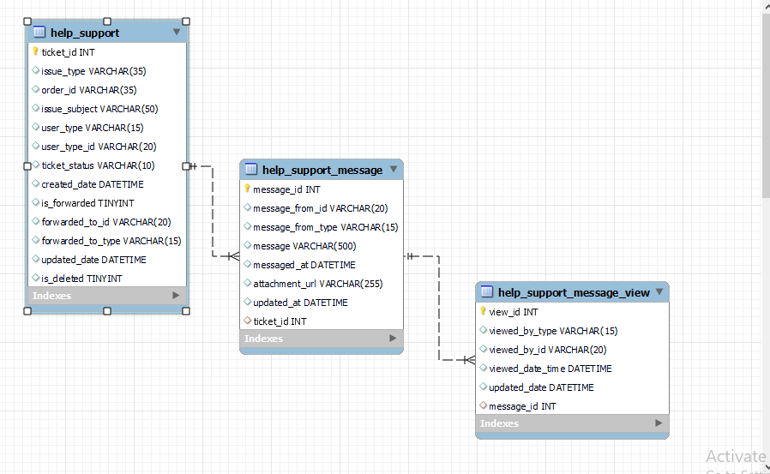

**Schema: db_mrmrscart_help_support**

**Table name: help_support**

**Table Description: This is to store the ticket details**

|  |  |  |  |
| --- | --- | --- | --- |
| COLUMN NAME | DATA TYPE | CONSTRAINTS | DESCRIPTION |
| ticket_id | INT | NOT NULL, AUTO_INCREMENT, PK | This is the primary key of the table, it is auto generated |
| issue_type | VARCHAR(35) | NOT NULL | This will store the type of issue each user |
| order_id | VARCHAR(35) |  | This will store the order id of the user |
| issue_subject | VARCHAR(50) | NOT NULL | This will store the subject of the user’s issue |
| user_type | VARCHAR (15) | NOT NULL | This will store the role of user who has raised the ticket |
| user_type_id | VARCHAR(20) | NOT NULL | This will store the id of the user who has raised the ticket |
| ticket_status | VARCHAR(10) | NOT NULL | This will store the status of the ticket |
| created_date | DATETIME | NOT NULL | This will store the ticket created date |
| is_forwarded | TINYINT |  | This will store whether the ticket is forwarded or not |
| forwarded_to_id | VARCHAR(20) |  | This will store the id of forwarded user |
| forwarded_to_type | VARCHAR(15) |  | This will store the type/role of the forwarded user |
| updated_date | DATETIME | NOT NULL | This will store the last updated date of the record |
| Is_deleted | TINYINT |  | This is used for soft delete |

**Schema: db_mrmrscart_help_support**

**Table name: help_support_message**

**Table Description: This is to store the message details of the ticket**

|  |  |  |  |
| --- | --- | --- | --- |
| COLUMN NAME | DATATYPE | CONSTRAINTS | DESCRIPTION |
| message_id | INT | NOT NULL, AUTO_INCREMENT, PK | This is the primary key of the table, it is auto generated |
| message_from_id | VARCHAR (20) | NOT NULL | This will store the user id from whom message is received |
| message_from_type | VARCHAR (20) | NOT NULL | This will store the type/role from whom message is received |
| message | VARCHAR (500) |  | This will store the message received by the user |
| messaged_at | DATETIME |  | This will store the message received date |
| attachment_url | VARCHAR (255) |  | This will store the url of the attachment received |
| updated_at | DATETIME |  | This will store the last updated date of the record |
| ticket_id | INT | FK | This is the foreign key from **help_support table**  (one to many) |

**Schema: db_mrmrscart_help_support**

**Table name: help_support_message_view**

**Table Description: This is to store the viewer details of help and support message**

|  |  |  |  |
| --- | --- | --- | --- |
| Column Name | Data Type | Constraints | Description |
| view_id | INT | NOT NULL, AUTO_INCREMENT, PK | This will store the primary key ,it is auto generated |
| viewed_by_type | VARCHAR(20) | NOT NULL | This will store the type/role of the message viewer |
| viewed_by_id | VARCHAR(30) | NOT NULL | This will store the id of the message viewer |
| viewed_date_time | DATETIME | NOT NULL | This will store the date of the message viewed |
| updated_date_time | DATETIME | NOT NULL | This will store the last updated date of the record |
| message_id | INT | FK | This is the foreign key from **help_support_message table**  (one to many) |

**Supplier Registration and Login Database ER Diagram**

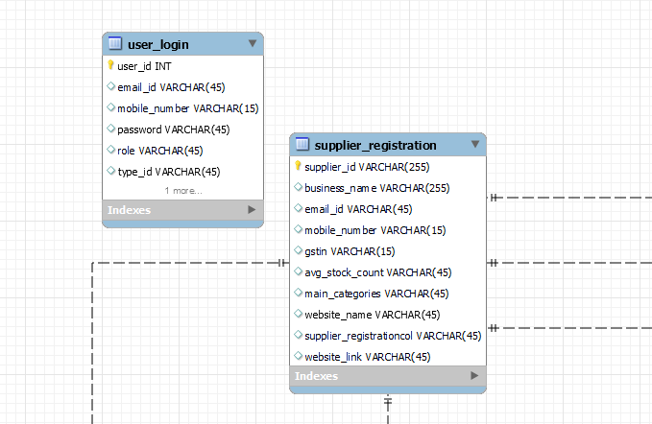

**Schema: db_mrmrscart**

**Table name: supplier_registration**

**Table Description: This is to store the supplier registration details.**

|  |  |  |  |
| --- | --- | --- | --- |
| COLUMN NAME | DATA TYPE | CONSTRAINTS | DESCRIPTION |
| supplier_id | INT | NOT NULL, AUTO_INCREMENT, PK | This is the primary key of the table, it is auto generated |
| business_name | VARCHAR(255) | NOT NULL | This will store the supplier business name |
| email_id | VARCHAR(45) | NOT NULL | This will store the supplier mail id |
| mobile_number | VARCHAR(15) | NOT NULL | This will store the supplier mobile number |
| gstin | VARCHAR(15) | NOT NULL | This will store the supplier gstin number |
| avg_stock_count | VARCHAR(45) | NOT NULL | This will store the average stock count of the supplier products |
| main_categories | VARCHAR(45) | NOT NULL | This will store the categories which is added by the supplier to his store |
| website_name | VARCHAR(255) |  | This will store the supplier other store in other application website names |
| website_link | VARCHAR(255) |  | This will store the supplier other store in other application website link |

**Schema: db_mrmrscart**

**Table name: user_login**

**Table Description: This is to store the user login details.**

|  |  |  |  |
| --- | --- | --- | --- |
| COLUMN NAME | DATA TYPE | CONSTRAINTS | DESCRIPTION |
| user_id | VARCHAR(255) | NOT NULL, AUTO_INCREMENT, PK | This is the primary key of the table, it is auto generated |
| email_id | VARCHAR(45) | NOT NULL | This will store the user mail id |
| mobile_number | VARCHAR(15) | NOT NULL | This will store the supplier mobile number |
| password | VARCHAR(45) | NOT NULL | This will store the user password |
| role | VARCHAR(45) | NOT NULL | This will store the role of the user |
| Type_id | VARCHAR(45) | NOT NULL | This will store the type id of the user |

**Supplier bank details database ER design**

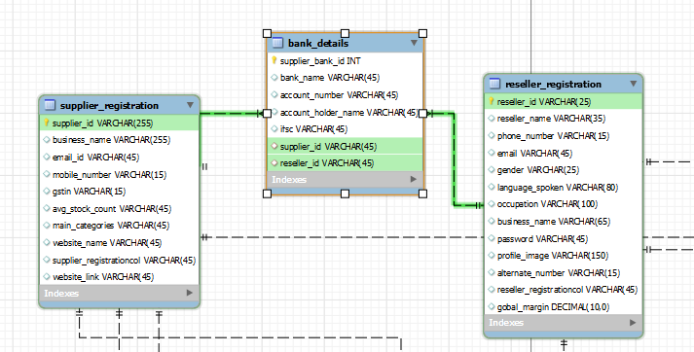

**Schema: db_mrmrscart**

**Table name: supplier_bank_details**

**Table Description: This is to store the supplier bank details .**

|  |  |  |  |
| --- | --- | --- | --- |
| COLUMN NAME | DATA TYPE | CONSTRAINTS | DESCRIPTION |
| supplier_bank_id | INT | NOT NULL, AUTO_INCREMENT, PK | This is the primary key of the table, it is auto generated |
| bank_name | VARCHAR(45) | NOT NULL | This will store the supplier bank details |
| account_number | VARCHAR(45) | NOT NULL | This will store the supplier account number |
| account_holder_name | VARCHAR(45) | NOT NULL | This will store the supplier user password |
| ifsc | VARCHAR(45) | NOT NULL | This will store the role of the user |
| supplier_id | VARCHAR(45) | FK | This will store the supplier id of the supplier registration table |
| reseller_id | VARCHAR(45) | FK | This will store the reseller id of the reseller registration table |

**Supplier address details database ER design**

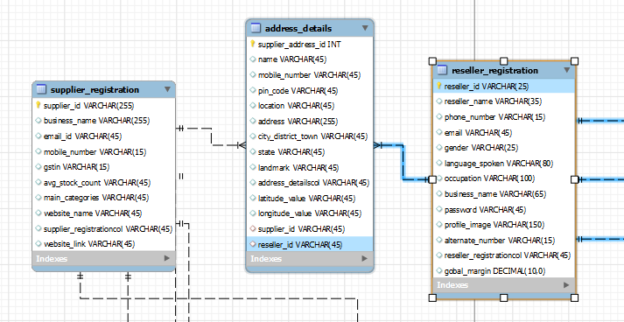

**Schema: db_mrmrscart**

**Table name: supplier_address_details**

**Table Description: This is to store the supplier address details.**

|  |  |  |  |
| --- | --- | --- | --- |
| COLUMN NAME | DATA TYPE | CONSTRAINTS | DESCRIPTION |
| supplier_address_id | INT | NOT NULL, AUTO_INCREMENT, PK | This is the primary key of the table, it is auto generated |
| name | VARCHAR(45) | NOT NULL | This will store the supplier business name |
| mobile_number | VARCHAR(15) | NOT NULL | This will store the supplier mobile number |
| pin_code | VARCHAR(45) | NOT NULL | This will store the supplier pincode |
| location | VARCHAR(45) | NOT NULL | This will store the supplier location |
| address | VARCHAR(255) | NOT NULL | This will store the supplier address |
| city_district_town | VARCHAR(255) | NOT NULL | This will store the supplier city, district, and town |
| state | VARCHAR(50) | NOT NULL | This will store the supplier state |
| landmark | VARCHAR(255) | NOT NULL | This will store the supplier landmark |
| alternative_mobile_number | VARCHAR(15) |  | This will store the supplier alternative mobile number |
| latitude_value | VARCHAR(45) |  | This will store the latitude value |
| longitude_value | VARCHAR(45) |  | This will store the longitude value |
| supplier_id | VARCHAR(45) | FK | This will store the supplier id of the supplier registration table |
| reseller_id | VARCHAR(45) | FK | This will store the reseller id of the reseller registration table |

Product-Coupons Database ER Diagram

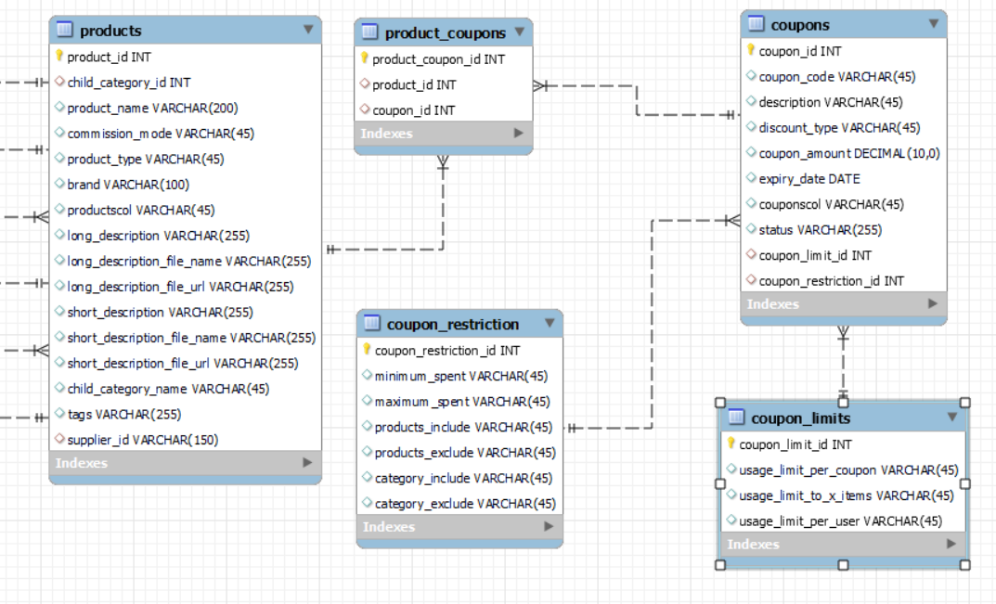

**Schema: db_mrmrscart**

**Table name: product_coupons**

**Table Description: This is to store the coupon and product relativity**

|  |  |  |  |
| --- | --- | --- | --- |
| COLUMN NAME | DATA TYPE | CONSTRAINTS | DESCRIPTION |
| product_coupon_id | INT | NOT NULL, AUTO_INCREMENT, PK | This is the primary key of the table; it is auto generated |
| product_id | INT | NOT NULL, FK | This will store the id of the product for the coupon |
| coupon_id | INT | NOT NULL, FK | This will store the coupon id for the product |

**Schema: db_mrmrscart**

**Table name: coupons**

**Table Description: This is to store the coupon details of the product**

|  |  |  |  |
| --- | --- | --- | --- |
| COLUMN NAME | DATATYPE | CONSTRAINTS | DESCRIPTION |
| coupon_id | INT | NOT NULL, AUTO_INCREMENT, PK | This is the primary key of the table; it is auto generated |
| coupon_code | VARCHAR (45) | NOT NULL | This will store the coupon code for the created coupon |
| description | VARCHAR (45) | NOT NULL | This will store the description about the coupon |
| discount_type | VARCHAR (45) | NOT NULL | This will store the type of discount of the coupon |
| coupon_amount | DECIMAL (10,0) | NOT NULL | This will store the amount of the coupon |
| expiry_date | DATE | NOT NULL | This will store the expiry date of the coupon |
| status | VARCHAR (255) | NOT NULL | This will store the status of the coupon |
| coupon_limit_id | INT | NOT NULL, FK | This will store the coupon limit id from the coupon_limit table |
| coupon_restriction_id | INT | NOT NULL, FK | This will store the coupon restriction id from the coupon_restriction table |

**Schema: db_mrmrscart**

**Table name: coupons_limit**

**Table Description: This is to store the coupon limit details**

|  |  |  |  |
| --- | --- | --- | --- |
| Column Name | Data Type | Constraints | Description |
| coupon_limit_id | INT | NOT NULL, AUTO_INCREMENT, PK | This is the primary key of the table; it is auto generated |
| usage_limit_per_coupon | VARCHAR(45) | NOT NULL | This will store the usage limit of a coupon |
| usage_limit_to_x_items | VARCHAR(45) | NOT NULL | This will store the limit to number of items for the coupon |
| usage_limit_per_user | VARCHAR(45) | NOT NULL | This will store the coupon usage limit for the user |

**Schema: db_mrmrscart**

**Table name: coupons_restriction**

**Table Description: This is to store the coupon restriction details**

|  |  |  |  |
| --- | --- | --- | --- |
| Column Name | Data Type | Constraints | Description |
| coupon_restriction_id | INT | NOT NULL, AUTO_INCREMENT, PK | This is the primary key of the table; it is auto generated |
| minimum_spent | VARCHAR(45) | NOT NULL | This will store the minimum order value |
| maximum_spent | VARCHAR(45) | NOT NULL | This will store the maximum order value |
| prodcuts_include | VARCHAR(45) | NOT NULL | This will store the products to be included |
| products_exclude | VARCHAR(45) | NOT NULL | This will store the products to be excluded |
| category_include | VARCHAR(45) | NOT NULL | This will store the categories to be included |
| category_exclude | VARCHAR(45) | NOT NULL | This will store the categories to be excluded |

MrMrsCart Orders ER Diagram

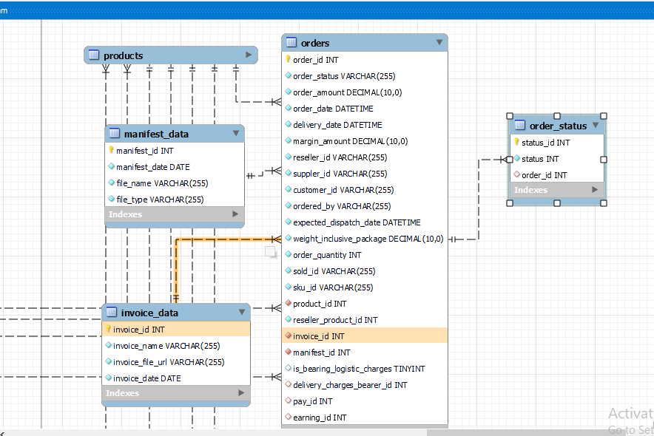

**Schema: mrmrscart**

**Table name: orders**

**Table Description: This is to store the order details**

|  |  |  |  |
| --- | --- | --- | --- |
| COLUMN NAME | DATA TYPE | CONSTRAINTS | DESCRIPTION |
| order_id | INT | NOT NULL, AUTO_INCREMENT, PK | This is the primary key of the table, it is auto generated |
| order_status | VARCHAR(35) | NOT NULL | This will store the order status for each order |
| price | DECIMAL(10,0) | NOT NULL | This will store the price of the product ordered |
| order_date | DATETIME | NOT NULL | This will store the date of the product ordered |
| delivery_date | DATETIME | NOT NULL | This will store the delivery date of the product ordered |
| margin_amount | DECIMAL(10,0) | NOT NULL | This will store the margin amount of the product ordered |
| reseller_id | VARCHAR (20) | NOT NULL | This will store the id of the reseller |
| suppler_id | VARCHAR (20) | NOT NULL | This will store the id of the supplier |
| customer_id | VARCHAR (20) |  | This will store the id of the customer |
| order_by_type | VARCHAR (15) | NOT NULL | This will store the type/role by whom product is ordered |
| weight_inclusive_package | DECIMAL(10,0) | NOT NULL | This will store weight of the product including package weight |
| expected_dispatch_date | DATETIME | NOT NULL | This will store the expected dispatch date of the product from supplier |
| order_quantity | INT | NOT NULL | This will store the quantity of the product ordered |
| sold_id | VARCHAR (20) | NOT NULL | This will store the id of the user from whom product is sold |
| sku_id | VARCHAR (35) | NOT NULL | This will store the SKU of the product |
| reseller_product_id | INT |  | This will store the id of the reseller’s product |
| invoice_id | INT | FK | This is the Foreign key from invoice_data table (one to one) |
| manifest_id | INT | FK | This is the Foreign key from manifest_data table (one to one) |
| product_id | INT | FK | This is the Foreign key from products table (one to many) |

**Schema: mrmrscart**

**Table name: orders_status**

**Table Description: This is to store the order status details**

|  |  |  |  |
| --- | --- | --- | --- |
| COLUMN NAME | DATATYPE | CONSTRAINTS | DESCRIPTION |
| status_id | INT | NOT NULL, AUTO_INCREMENT, PK | This is the primary key of the table, it is auto generated |
| status | VARCHAR (35) |  | This will store the status of the order from dispatch to delivery to customer |
| created_at | DATETIME | NOT NULL | This will store the created date of the record |
| updated_at | DATETIME | NOT NULL | This will store the updated date of the record |
| order_id | INT | FK | This is the foreign key from Orders table (One to many) |

**Schema: mrmrscart**

**Table name: invoice_data**

**Table Description: This is to store the invoice details for the order**

|  |  |  |  |
| --- | --- | --- | --- |
| Column Name | Data Type | Constraints | Description |
| invoice_id | INT | NOT NULL, AUTO_INCREMENT, PK | This will store the primary key ,it is auto generated |
| invoice_name | VARCHAR(255) | NOT NULL | This will store the name of the generated invoice |
| invoice_file_url | VARCHAR(255) | NOT NULL | This will store the url of the invoice file |
| invoice_date | DATETIME | NOT NULL | This will store the generated invoice date |
| updated_date | DATETIME | NOT NULL | This will store the updated date of the record |

**Schema: mrmrscart**

**Table name: manifest_data**

**Table Description: This is to store the manifest details for the order**

|  |  |  |  |
| --- | --- | --- | --- |
| Column Name | Data Type | Constraints | Description |
| manifest_id | BIGINT() | NOT NULL, AUTO_INCREMENT, PK | This will store the primary key ,it is auto generated |
| manifest_date | DATETIME | NOT NULL | This will store the manifest generated date |
| manifest_file_url | VARCHAR (255) | NOT NULL | This will store the url of the manifest file |
| manifest_file_name | VARCHAR (255) | NOT NULL | This will store the name of the manifest file |
| updated_date | DATETIME | NOT NULL | This will store the last updated date of the record |

Payment-Info Database ER Diagram

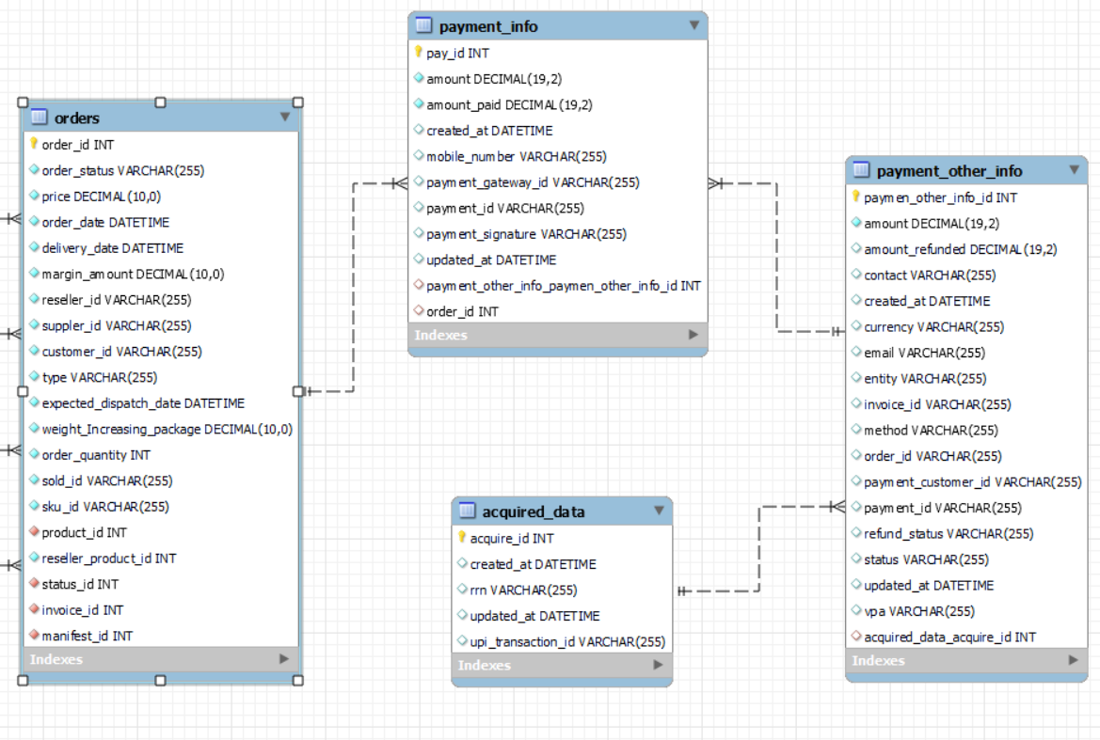

**Schema: db_mrmrscart**

**Table name: payment_info**

**Table Description: This is to store the payment information of the orders**

|  |  |  |  |
| --- | --- | --- | --- |
| Column Name | Data Type | Constraints | Description |
| pay_id | INT | NOT NULL, AUTO_INCREMENT, PK | This is the primary key of the table; it is auto generated |
| amount | DECIMAL(19,2) | NOT NULL | This will store the order amount |
| amount_paid | DECIMAL(19,2) | NOT NULL | This will store the paid amount |
| created_at | DATETIME | NOT NULL | This will store the creation date |
| mobile_number | VARCHAR(255) | NOT NULL | This will store the mobile number |
| payment_gateway_id | VARCHAR(255) | NOT NULL | This will store the payment gateway id |
| payment_id | VARCHAR(255) | NOT NULL | This will store the payment id |
| payment_signature | VARCHAR(255) | NOT NULL | This will store the payment signature |
| updated_at | DATETIME | NOT NULL | This will store the updating date |
| payment_other_info_payment_other_info_id | INT | NOT NULL, FK | This will store the payment other info id, which is a primary key in payment_other_info table |
| order_id | INT | NOT NULL, FK | This will store the order id, which is the primary key in orders table |

**Schema: db_mrmrscart**

**Table name: payment_other_info**

**Table Description: This is to store the payment information of the orders**

|  |  |  |  |
| --- | --- | --- | --- |
| Column Name | Data Type | Constraints | Description |
| paymen_other_info_id | INT | NOT NULL, AUTO_INCREMENT, PK | This is the primary key of the table; it is auto generated |
| amount | DECIMAL(19,2) | NOT NULL | This will store the order amount |
| amount_refunded | DECIMAL(19,2) | NOT NULL | This will store the refunded amount |
| contact | VARCHAR(255) | NOT NULL | This will store the contact number |
| created_at | DATETIME | NOT NULL | This will store the creation date |
| currency | VARCHAR(255) | NOT NULL | This will store the type of currency used for payment |
| email | VARCHAR(255) | NOT NULL | This will store the email id of the customer |
| entity | VARCHAR(255) | NOT NULL | This will store the entity of the payment |
| invoice_id | VARCHAR(255) | NOT NULL | This will store the invoice id |
| method | VARCHAR(255) | NOT NULL | This will store the payment method |
| order_id | VARCHAR(255) | NOT NULL | This will store the order id |
| payment_customer_id | VARCHAR(255) | NOT NULL | This will store the customer id who made the payment |
| payment_id | VARCHAR(255) | NOT NULL | This will store the payment id |
| refund_status | VARCHAR(255) | NOT NULL | This will store the refund status |
| status | VARCHAR(255) | NOT NULL | This will store the status of the payment |
| updated_at | DATETIME |  | This will store the updating date |
| vpa | VARCHAR(255) | NOT NULL | This will store the virtual payment address |
| acquired_data_acquire_id | INT | NOT NULL, FK | This will store the order id, which is the primary key in orders table |

**Schema: db_mrmrscart**

**Table name: payment_other_info**

**Table Description: This is to store the payment information of the orders**

|  |  |  |  |
| --- | --- | --- | --- |
| Column Name | Data Type | Constraints | Description |
| acquire_id | INT | NOT NULL, AUTO_INCREMENT, PK | This is the primary key of the table; it is auto generated |
| created_at | DATETIME | NOT NULL | This will store the creation date |
| rrn | VARCHAR(45) | NOT NULL | This will store the reference number of the transaction |
| updated_at | DATETIME |  | This will store the updating date |
| upi_transaction_id | VARCHAR(45) | NOT NULL | This will store the upi transaction id |

**Staff Management ER Diagram**

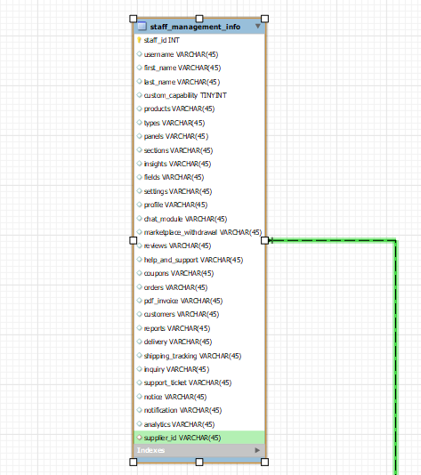

**Schema: db_mrmrscart**

**Table name: staff_management**

**Table Description: This is to store the staff details.**

|  |  |  |  |
| --- | --- | --- | --- |
| COLUMN NAME | DATA TYPE | CONSTRAINTS | DESCRIPTION |
| staff _id | VARCHAR(100) | NOT NULL, AUTO_INCREMENT, PK | This is the primary key of the table, it is auto generated |
| username | VARCHAR(45) | NOT NULL | This will store the staff username |
| first_name | VARCHAR(45) | NOT NULL | This will store the staff first name |
| last_name | VARCHAR(45) | NOT NULL | This will store the staff last name |
| custom_capability | tinyint |  | This will store the value of custom capability whether it is true or false |
| products | VARCHAR(45) |  | This will store the object of boolean values related to product tab. |
| types | VARCHAR(45) |  | This will store the object of boolean values related to types tab. |
| panels | VARCHAR(45) |  | This will store the object of boolean values related to panels tab. |
| sections | VARCHAR(45) |  | This will store the object of boolean values related to sections tab. |
| insights | VARCHAR(45) |  | This will store the object of boolean values related to insights tab. |
| fields | VARCHAR(45) |  | This will store the object of boolean values related to fields tab. |
| settings | VARCHAR(45) |  | This will store the object of boolean values related to settings tab. |
| profile | VARCHAR(45) |  | This will store the object of boolean values related to profile tab. |
| chat_module | VARCHAR(45) |  | This will store the object of boolean values related to chat module tab. |
| marketplace_withdrawal | VARCHAR(45) |  | This will store the object of boolean values related to marketplace withdrawal tab. |
| reviews | VARCHAR(45) |  | This will store the object of boolean values related to reviews tab. |
| help_and_support | VARCHAR(45) |  | This will store the object of boolean values related to help and support tab. |
| coupons | VARCHAR(45) |  | This will store the object of boolean values related to coupons tab. |
| orders | VARCHAR(45) |  | This will store the object of boolean values related to orders tab. |
| pdf_invoice | VARCHAR(45) |  | This will store the object of boolean values related to pdf invoice tab. |
| customers | VARCHAR(45) |  | This will store the object of boolean values related to customers tab. |
| reports | VARCHAR(45) |  | This will store the object of boolean values related to reports tab. |
| delivery | VARCHAR(45) |  | This will store the object of boolean values related to delivery tab. |
| shipping_tracking | VARCHAR(45) |  | This will store the object of boolean values related to shipping tracking tab. |
| inquiry | VARCHAR(45) |  | This will store the object of boolean values related to inquiry tab. |
| support_ticket | VARCHAR(45) |  | This will store the object of boolean values related to support ticket tab. |
| notice | VARCHAR(45) |  | This will store the object of boolean values related to notice tab. |
| notification | VARCHAR(45) |  | This will store the object of boolean values related to notification tab. |
| analytics | VARCHAR(45) |  | This will store the object of boolean values related to analytics tab. |
| supplier_id | VARCHAR(45) | FK | This will store the supplier id of the supplier registration table |

MrMrsCart Products ER Diagram

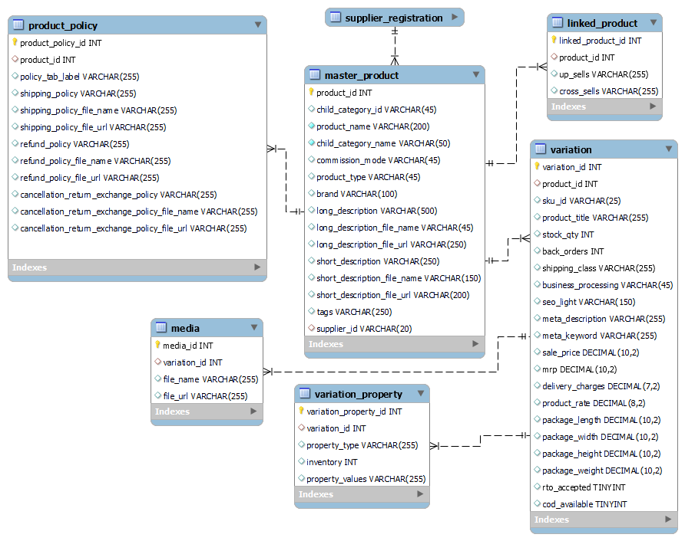

**Schema: mrmrscart**

**Table name: master_product**

**Table Description: This is to store the product details**

|  |  |  |  |
| --- | --- | --- | --- |
| COLUMN NAME | DATA TYPE | CONSTRAINTS | DESCRIPTION |
| product_id | INT | NOT NULL, AUTO_INCREMENT, PK | This is the primary key of the table, it is auto generated |
| child_category_id | INT |  | This will store the child category id |
| child_category_name | VARCHAR(50) |  | This will store the child category name |
| product_name | VARCHAR (200) | NOT NULL | This will store the name of the product |
| commission_mode | VARCHAR (45) |  | This will store the commission mode of the product |
| product_type | VARCHAR (45) | NOT NULL | This will store the product type of the product |
| brand | VARCHAR (100) |  | This will store the product brand |
| long_description | VARCHAR (500) |  | This will store the long description of the product |
| long_description_file_name | VARCHAR (150) |  | This will store the long description file name of the product |
| long_description_file_url | VARCHAR (200) |  | This will store the long description file URL |
| short_description | VARCHAR (250) |  | This will store the short description of the product |
| short_description_file_name | VARCHAR (150) |  | This will store the short description file name of the product |
| short_description_file_url | VARCHAR (200) |  | This will store the short description file URL of the product |
| tags | VARCHAR (250) |  | This will store the tags of the product |
| supplier_id | VARCHAR(20) | FK | This will store the supplier id as a foreign key |

**Schema: mrmrscart**

**Table name: linked_product**

**Table Description: This is to store the linked details about a product**

|  |  |  |  |
| --- | --- | --- | --- |
| COLUMN NAME | DATATYPE | CONSTRAINTS | DESCRIPTION |
| linked_id | INT | NOT NULL, AUTO_INCREMENT, PK | This is the primary key of the table, it is auto generated |
| product_id | INT | FK | This will store the product id as a foreign key |
| up_sells | VARCHAR (255) |  | This will store the upsells details of the product |
| cross_sells | VARCHAR (255) |  | This will store the cross sells of the product |

**Schema: mrmrscart**

**Table name: product_policy**

**Table Description: This is to store the product policies**

|  |  |  |  |
| --- | --- | --- | --- |
| Column Name | Data Type | Constraints | Description |
| product_policy_id | INT | NOT NULL, AUTO_INCREMENT, PK | This will store the primary key ,it is auto generated |
| product_id | INT | FK | This will store the product id as foreign key |
| policy_tab_label | VARCHAR (255) |  | This will store the policy tab label |
| shipping_policy | VARCHAR (255) |  | This will store the shipping policy of the product |
| shipping_policy_file_name | VARCHAR (255) |  | This will store the shipping policy file name of the product |
| shipping_policy_file_url | VARCHAR (255) |  | This will store the shipping policy file url of the product |
| refund_policy | VARCHAR (255) |  | This will store the refund policy of the product |
| refund_policy_file_name | VARCHAR (255) |  | This will store the refund policy file name of the product |
| refund_policy_file_url | VARCHAR(255) |  | This will store the refund policy file url of the product |
| cancellation_return_exchange_policy | VARCHAR(255) |  | This will store the cancellation or return or exchange policy of the product |
| cancellation_return_exchange_policy  _file_name | VARCHAR(255) |  | This will store the cancellation or return or exchange policy file name of the product |
| cancellation_return_exchange_policy  _file_url | VARCHAR(255) |  | This will store the cancellation or return or exchange policy file url of the product |

**Schema: mrmrscart**

**Table name: variation**

**Table Description: This is to store the variation details of the product**

|  |  |  |  |
| --- | --- | --- | --- |
| Column Name | Data Type | Constraints | Description |
| variation_id | INT | NOT NULL, AUTO_INCREMENT, PK | This will store the primary key ,it is auto generated |
| product_id | INT | FK | This will store the product id as a foreign key |
| sku_id | VARCHAR (25) | NOT NULL | This will store the sku id for the variation |
| product_title | VARCHAR (255) | NOT NULL | This will store the product title |
| stock_qty | INT |  | This will store the variation stock quantity |
| back_orders | INT |  | This will store the back orders |
| shipping_class | VARCHAR(255) |  | This will store the shipping class |
| business_processing  _days | VARCHAR(45) |  | This will store the business processing days |
| seo_light | VARCHAR(150) |  | This will store the SEO light |
| meta_description | VARCHAR (255) |  | This will store the meta description |
| meta_keyword | VARCHAR(255) |  | This will store the meta keyword |
| sale_price | DECIMAL(10,2) |  | This will store the sale price |
| mrp | DECIMAL(10,2) |  | This will store the mrp price |
| delivery_charges | DECIMAL(7,2) |  | This will store the delivery charges |
| product_rate | DECIMAL(8,2) |  | This will store the product rate |
| package_length | DECIMAL(10,2) |  | This will store the package length |
| package_width | DECIMAL(10,2) |  | This will store the package width |
| package_height | DECIMAL(10,2) |  | This will store the package height |
| package_weight | DECIMAL(10,2) |  | This will store the package weight |
| rto_accepted | TINYINT |  | This will store the rto acceptance |
| cod_available | TINYINT |  | This will store the cod available |

**Schema: mrmrscart**

**Table name: variation_property**

**Table Description: This is to store the properties of each variation**

|  |  |  |  |
| --- | --- | --- | --- |
| Column Name | Data Type | Constraints | Description |
| variation_property_id | INT | NOT NULL, AUTO_INCREMENT, PK | This will store the primary key ,it is auto generated |
| variation_id | INT | FK | This will store the variation id as a foreign key |
| property_type | VARCHAR(255) |  | This will store the property type |
| inventory | INT |  | Tis will store the inventory |
| property_values | VARCHAR(255) |  | This will store the |

**Schema: mrmrscart**

**Table name: media**

**Table Description: This is to store the media details**

|  |  |  |  |
| --- | --- | --- | --- |
| Column Name | Data Type | Constraints | Description |
| media_id | INT | NOT NULL, AUTO_INCREMENT, PK | This will store the primary key ,it is auto generated |
| variation_id | INT | FK | This will store the variation id as foreign key |
| file_name | VARCHAR (255) | NOT NULL | This will store the file name |
| file_url | VARCHAR (255) | NOT NULL | This will store the URL of the file |

**RESELLER MODULE**

**Reseller Registration Database ER diagram**

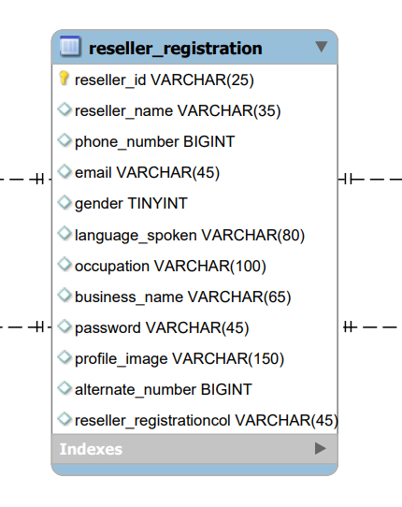

**Schema: mrmrscart**

**Table name: reseller_registration**

**Table Description: This is to store the reseller registration details.**

|  |  |  |  |
| --- | --- | --- | --- |
| Column Name | Data Type | Constraints | Description |
| reseller_id | VARCHAR(100) | NOT NULL, AUTO_INCREMENT, PK | This will store the primary key ,it is auto generated |
| reseller_name | VARCHAR(45) | Not null | This will store the name of the reseller |
| phone_number | VARCHAR (15) | Not null | This will store the phone number of the reseller |
| email | VARCHAR (45) | Not null | This will store the email of the reseller |
| gender | VARCHAR (20) | Not null | This will store the gender of the reseller |
| language_spoken | VARCHAR (80) |  | This will store the language spoken detail of the reseller |
| occupation | VARCHAR (100) |  | This will store the occupation of the reseller |
| business_name | VARCHAR (65) | Not null | This will store the business name of the reseller |
| password | VARCHAR(45) | Not null | This will store the password of the reseller |
| profile_image | VARCHAR(150) |  | This will store the profile image link of the reseller |
| alternate_number | VARCHAR(15) |  | This will store the alternate number of the reseller |

**Reseller Shop Database ER Design**

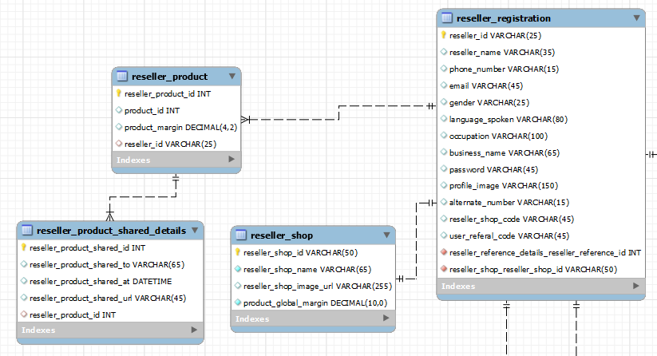

**Schema: mrmrscart**

**Table name: reseller_shop**

**Table Description: This is to store the reseller shop details.**

|  |  |  |  |
| --- | --- | --- | --- |
| Column Name | Data Type | Constraints | Description |
| shop_id | INT | NOT NULL, AUTO_INCREMENT, PK | This will store the primary key ,it is auto generated |
| shop_name | VARCHAR(100) | Not null | This will store the reseller shop name |
| shop_code | VARCHAR (50) | NOT NULL | This will store the shop code of reseller |
| shop_image_url | VARCHAR (255) |  | This will store the image URL of the reseller shop |
| reseller_registration_  reseller_shop | VARCHAR (25) | FK | This will store the if of reseller |

**Schema: mrmrscart**

**Table name: reseller_product**

**Table Description: This is to store the reseller product details.**

|  |  |  |  |
| --- | --- | --- | --- |
| Column Name | Data Type | Constraints | Description |
| reseller_product_shared_id | INT | NOT NULL, AUTO_INCREMENT, PK | This will store the primary key ,it is auto generated |
| reseller_product_shared_to | VARCHAR (65) | Not null | This will store the data of for whom the product is shared |
| reseller_product_shared_at | DATETIME |  | This will store the date and time of the product shared |
| reseller_product_shared_url | VARCHAR(255) |  | This will store the url of the product shared |
| reseller_product_id | INT | FK | This will store the reseller product ID |

**Schema: mrmrscart**

**Table name: reseller_product shared_details**

**Table Description: This is to store the reseller product shared details.**

|  |  |  |  |
| --- | --- | --- | --- |
| Column Name | Data Type | Constraints | Description |
| reseller_product_id | INT | NOT NULL, AUTO_INCREMENT, PK | This will store the primary key ,it is auto generated |
| margin | DECIMAL(4.2) | Not null | This will store the margin for the reseller products |
| reseller_id | VARCHAR (25) | FK | This will store the reseller id |
| master_product_id | INT | Not null | This will store the master product id |
| margin_type | VARCHAR (45) | Not null | This will store the margin type of the reseller products |

Earnings Database ER Diagram

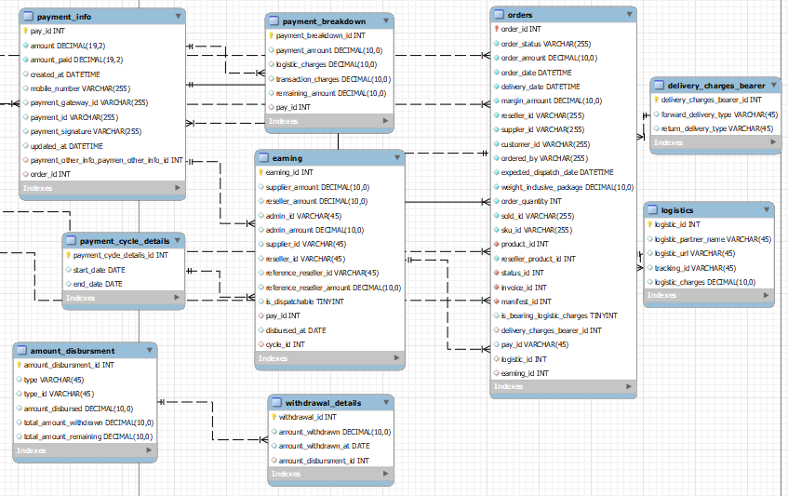

**Schema: mrmrscart**

**Table name: earning**

**Table Description: This is to store the earnings of supplier, reseller and admin**

|  |  |  |  |
| --- | --- | --- | --- |
| Column Name | Data Type | Constraints | Description |
| earning_id | INT | NOT NULL, AUTO_INCREMENT, PK | This will store the primary key ,it is auto generated |
| supplier_amount | DECIMAL(10,0) |  | This will store the supplier share amount |
| reseller_amount | DECIMAL(10,0) |  | This will store the reseller share amount |
| admin_amount | DECIMAL(10,0) |  | This will store the admin share amount |
| admin_id | DECIMAL(10,0) |  | This will store the admin id |
| supplier_id | VARCHAR(45) |  | This will store the supplier id |
| reseller_id | VARCHAR(45) |  | This will store the reseller id |
| reference_reseller_id | VARCHAR(45) |  | This will store the reference reseller id |
| reference_reseller_amount | DECIMAL(10,0) |  | This will store the commission of the reference reseller |
| is_dispatchable | TINYINT(0) |  | This will store the status of dispatch |
| pay_id | INT | FK | This is the primary key from the payment info table |
| disbursed_at | DATE |  | This will store the disbursement date |
| cycle_id | INT | FK | This is the primary key from payment cycle details table |

**Schema: mrmrscart**

**Table name: amount_disbursment**

**Table Description: This is to store the details of disbursed amount for supplier, reseller and admin**

|  |  |  |  |
| --- | --- | --- | --- |
| Column Name | Data Type | Constraints | Description |
| amount_disbursment_id | INT | NOT NULL, AUTO_INCREMENT, PK | This will store the primary key ,it is auto generated |
| type | VARCHAR(45) |  | This will store the type of user |
| type_id | VARCHAR(45) |  | This will store the user id |
| amount_disbursed | DECIMAL(10,0) |  | This will store the total disbursed amount |
| total_amount_withdrawn | DECIMAL(10,0) |  | This will store the total withdrawn amount |
| total_amount_remaining | DECIMAL(10,0) |  | This will store the total remaining amount |

**Schema: mrmrscart**

**Table name: withdrawal_details**

**Table Description: This is to store the details of withdrawals from the disbursed amount, by the supplier, reseller and admin**

|  |  |  |  |
| --- | --- | --- | --- |
| Column Name | Data Type | Constraints | Description |
| withdrawal_id | INT | NOT NULL, AUTO_INCREMENT, PK | This will store the primary key ,it is auto generated |
| amount_withdrawn | DECIMAL(10,0) |  | This will store the withdrawn amount |
| amount_withdrawn_at | DATE |  | This will store the date on which the withdrawal was done |
| amount_disbursment_id | INT | FK | This is the primary key from the amount disbursement table |

**Schema: mrmrscart**

**Table name: payment_cycle_details**

**Table Description: This is to store the details of the payment cycle**

|  |  |  |  |
| --- | --- | --- | --- |
| Column Name | Data Type | Constraints | Description |
| payment_cycle_details_id | INT | NOT NULL, AUTO_INCREMENT, PK | This will store the primary key ,it is auto generated |
| start_date | DATE | NOT NULL | This will store the start date of the cycle |
| end_date | DATE | NOT NULL | This will store the end date of the cycle |

**Schema: mrmrscart**

**Table name: payment_breakdown**

**Table Description: This is to store the details of the breakdown in the payment amount**

|  |  |  |  |
| --- | --- | --- | --- |
| Column Name | Data Type | Constraints | Description |
| payment_breakdown_id | INT | NOT NULL, AUTO_INCREMENT, PK | This will store the primary key ,it is auto generated |
| payment_amount | DECIMAL(10,0) |  | This will store the total amount received as payment |
| logistic_charges | DECIMAL(10,0) |  | This will store the logistic charges |
| transaction_charges | DECIMAL(10,0) |  | This will store the transaction charges |
| remaining_amount | DECIMAL(10,0) |  | This will store the amount remaining after the deductions |
| pay_id | INT |  | This is the primary key from the payment info table |

**Schema: mrmrscart**

**Table name: payment_breakdown**

**Table Description: This is to store the details of the breakdown in the payment amount**

|  |  |  |  |
| --- | --- | --- | --- |
| Column Name | Data Type | Constraints | Description |
| logistic_id | INT | NOT NULL, AUTO_INCREMENT, PK | This will store the primary key ,it is auto generated |
| logistic_partner_name | VARCHAR(45) |  | This will store the logistic partner name |
| logistic_url | VARCHAR(45) |  | This will store the |
| tracking_id | VARCHAR(45) |  | This will store the tracking id for a particular order |
| logistic_charges | DECIMAL(10,0) |  | This will store the logistic charges for a particular order |

**Schema: mrmrscart**

**Table name: delivery_charges_bearer**

**Table Description: This is to store the details the delivery charges bared by the customer**

|  |  |  |  |
| --- | --- | --- | --- |
| Column Name | Data Type | Constraints | Description |
| delivery_charges_bearer_id | INT | NOT NULL, AUTO_INCREMENT, PK | This will store the primary key ,it is auto generated |
| forward_delivery_type | VARCHAR(45) |  | This will store the delivery charges |
| return_delivery_type | VARCHAR(45) |  | This will store the returning charges |

**Referred Reseller Database ER Diagram**

**Schema: mrmrscart**

**Table name: reseller_reference_details**

**Table Description: This table is used to store the details of reseller reference details.**

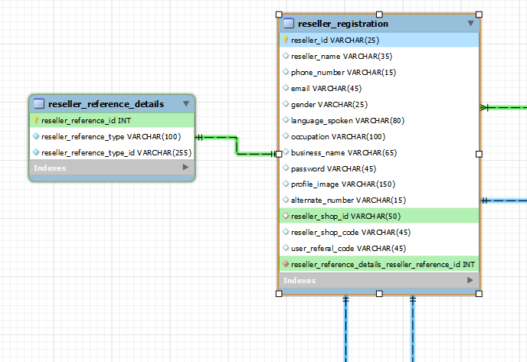

|  |  |  |  |
| --- | --- | --- | --- |
| Column Name | Data Type | Constraints | Description |
| reseller_reference_id | INT | NOT NULL, AUTO_INCREMENT, PK | This will store the primary key ,it is auto generated |
| reseller_reference _type | VARCHAR(100) | Not Null | This will store the type of referer |
| reseller_reference_ type_id | VARCHAR(45) | Not Null | This will store the type id of referrer |

**Notification Details ER Diagram**

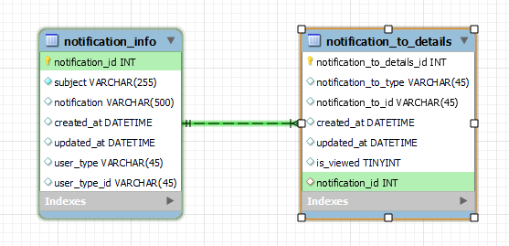

**Schema: mrmrscart**

**Table name: notification_info**

**Table Description: This table is used to store the notification details.**

|  |  |  |  |
| --- | --- | --- | --- |
| Column Name | Data Type | Constraints | Description |
| notification_id | INT | NOT NULL, AUTO_INCREMENT, PK | This will store the primary key ,it is auto generated |
| subject | VARCHAR(100) | Not Null | This will store the subject of the notification |
| notification | VARCHAR(45) | Not Null | This will store the notification |
| created_at | DATETIME | Not Null | This will store the date and time of the notification created |
| updated_at | DATETIME | Not Null | This will store the date and time of the notification updated |
| user_type | VARCHAR(45) | Not Null | This will store the user type |
| user_type_id | VARCHAR(45) | Not Null | This will store the type id |

**Schema: mrmrscart**

**Table name: notification_to_details**

**Table Description: This table is used to store the notification details.**

|  |  |  |  |
| --- | --- | --- | --- |
| Column Name | Data Type | Constraints | Description |
| notification_to_details_id | INT | NOT NULL, AUTO_INCREMENT, PK | This will store the primary key ,it is auto generated |
| notification_to_type | VARCHAR(100) | Not Null | This will store the notification type |
| notification_to_id | VARCHAR(45) | Not Null | This will store the notification type |
| created_at | DATETIME | Not Null | This will store the date and time of the notification sent |
| updated_at | DATETIME | Not Null | This will store the date and time of the notification updated |
| is_viewed | TINYINT |  | This will store the Boolean value is viewed or not |
| Notification_id | INT | FK | This wills store the notification id from the notification info table |

**Schema: mrmrscart**

**Table name: customer**

**Table Description: This is to store the customer details**

|  |  |  |  |
| --- | --- | --- | --- |
| COLUMN NAME | DATA TYPE | CONSTRAINTS | DESCRIPTION |
| customer_id | BIGINT | NOT NULL, AUTO_INCREMENT, PK | This is the primary key of the table, it is auto generated |
| customer_name | VARCHAR(20) | NOT NULL | This will store the name for each customer |
| phone_number | VARCHAR (10) | NOT NULL, UNIQUE | This will store the phone number of the customer |
| email | VARCHAR (45) | NOT NULL, UNIQUE | This will store the email-id of the customer |
| gender | VARCHAR (10) | NOT NULL | This will store the gender of the user |
| profile_image | VARCHAR (50) |  | This will store the url of the profile picture of the customer |
| cart_id | BIGINT |  | This is FK from user_cart table(one to one) |

**Schema: mrmrscart**

**Table name: wishlist**

**Table Description: This is to store the wishlist details**

|  |  |  |  |
| --- | --- | --- | --- |
| COLUMN NAME | DATATYPE | CONSTRAINTS | DESCRIPTION |
| wishlist_id | BIGINT | NOT NULL, AUTO_INCREMENT, PK | This is the primary key of the table, it is auto generated |
| wishlist_name | VARCHAR (20) | NOT NULL | This will store the name of the wish list |
| type | VARCHAR (10) | NOT NULL | This will store the type of ownership |
| type_id | BIGINT | NOT NULL | This will store the type id |
| created_at | DATETIME |  | This will store the record created date |
| modified_at | DATETIME |  | This will store the record modified date |

**Schema: mrmrscart**

**Table name: user cart**

**Table Description: This is to store the cart id of customer**

|  |  |  |  |
| --- | --- | --- | --- |
| Column Name | Data Type | Constraints | Description |
| cart_id | BIGINT | NOT NULL, AUTO_INCREMENT, PK | This will store the primary key ,it is auto generated |
| created_at | DATETIME |  | This will store the record created date |
| modified_at | DATETIME |  | This will store the record modified date |

**Schema: mrmrscart**

**Table name: shopping_cart**

**Table Description: This is to store the cart details**

|  |  |  |  |
| --- | --- | --- | --- |
| Column Name | Data Type | Constraints | Description |
| shopping_cart_id | BIGINT | NOT NULL, AUTO_INCREMENT, FK | This will store the primary key ,it is auto generated |
| product_id | BIGINT | NOT NULL | This is a FK from product table(one to many) |
| cart_id | BIGINT | NOT NULL | This is a FK from user_cart table(one to many) |
| quantity | BIGINT | NOT NULL | This will store the product quantity |
| order_type | VARCHAR (10) | NOT NULL | This will store the type of the order |
| delivery_charge | double |  | This will store the delivery charge of the product |
| return_charge | double |  | This will store the product return charge |

**Schema: mrmrscart**

**Table name: wishlist_product**

**Table Description: This is to store the customer wishlist details**

|  |  |  |  |
| --- | --- | --- | --- |
| Column Name | Data Type | Constraints | Description |
| product_id | BIGINT | NOT NULL | This is a FK from customer table(one to many) |
| wishlist_id | BIGINT | NOT NULL | This is a FK from wishlist table(many to one) |